15 ДЗ - Профилирование запросов.
Собираем Dockerfile.
clickhouse-25.2.1.Dockerfile:
FROM clickhouse/clickhouse-server:25.2.1
MAINTAINER Maksim Kulikov <max.uoles@rambler.ru>

RUN apt-get update -y --fix-missing
RUN DEBIAN_FRONTEND=noninteractive apt-get -yq upgrade
RUN apt-get install nano mc python3 pip kafkacat -y
RUN pip install clickhouse_driver

EXPOSE 8123 9000

ENTRYPOINT ["/entrypoint.sh"]

Собираем образ командой:

docker build -f clickhouse-25.2.1.Dockerfile -t uoles/clickhouse:25.2.1 .

Запускаем:

docker run -d \
-p 18123:8123 \
-p 19000:9000 \
-e CLICKHOUSE_DB=my_database \
-e CLICKHOUSE_USER=username \
-e CLICKHOUSE_DEFAULT_ACCESS_MANAGEMENT=1 \
-e CLICKHOUSE_PASSWORD=password \
--name clickhouse-server \
--ulimit nofile=262144:262144 \
uoles/clickhouse:25.2.1

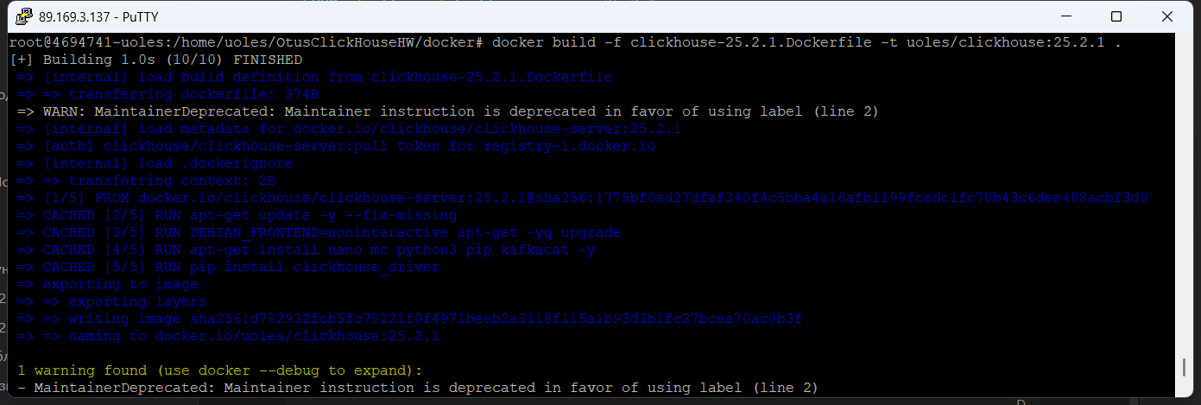

Создание таблицы и тестирование запросов.

Использую датасет (ежемесячное обновление):
https://clickhouse.com/docs/getting-started/example-datasets/uk-price-paid

Создаем таблицу и заполняем данными:

CREATE TABLE my_database.uk_price_paid
(
price UInt32,
date Date,
postcode1 LowCardinality(String),
postcode2 LowCardinality(String),
type Enum8('terraced' = 1, 'semi-detached' = 2, 'detached' = 3, 'flat' = 4, 'other' = 0),
is_new UInt8,
duration Enum8('freehold' = 1, 'leasehold' = 2, 'unknown' = 0),
addr1 String,
addr2 String,
street LowCardinality(String),
locality LowCardinality(String),
town LowCardinality(String),
district LowCardinality(String),
county LowCardinality(String)
)
ENGINE = MergeTree
ORDER BY (postcode1, postcode2, addr1, addr2);

INSERT INTO my_database.uk_price_paid
SELECT
toUInt32(price_string) AS price,
parseDateTimeBestEffortUS(time) AS date,
splitByChar(' ', postcode)[1] AS postcode1,
splitByChar(' ', postcode)[2] AS postcode2,
transform(a, ['T', 'S', 'D', 'F', 'O'], ['terraced', 'semi-detached', 'detached', 'flat', 'other']) AS type,
b = 'Y' AS is_new,
transform(c, ['F', 'L', 'U'], ['freehold', 'leasehold', 'unknown']) AS duration,
addr1,
addr2,
street,
locality,
town,
district,
county
FROM url(
'http://prod.publicdata.landregistry.gov.uk.s3-website-eu-west-1.amazonaws.com/pp-monthly-update-new-version.csv',
'CSV',
'uuid_string String,
price_string String,
time String,
postcode String,
a String,
b String,
c String,
addr1 String,
addr2 String,
street String,
locality String,
town String,
district String,
county String,
d String,
e String'
) SETTINGS max_http_get_redirects=10;

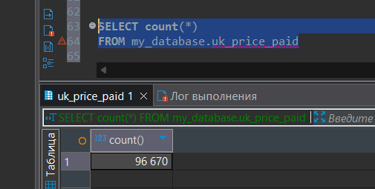

Проверяем использование индексов через лог.

Заходим в docker контейнер и подключаемся к clickhouse через clickhouse-client:
>> docker exec -it clickhouse-server clickhouse-client --user username --password password

Выставляем уровень логирования – trace:
>> SET send_logs_level = 'trace';

Проверяем запрос без primary_key поля:

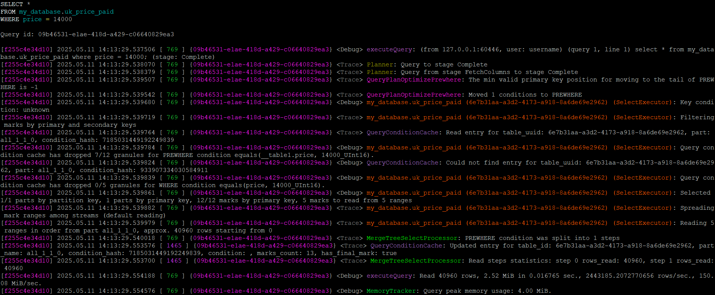

Записи лога с использованием индекса – видим, что pk не найден:

(SelectExecutor): Key condition: unknown
(SelectExecutor): Filtering marks by primary and secondary keys
(SelectExecutor): Query condition cache has dropped 7/12 granules for PREWHERE condition equals(__table1.price, 14000_UInt16).
(SelectExecutor): Query condition cache has dropped 0/5 granules for WHERE condition equals(price, 14000_UInt16).
(SelectExecutor): Selected 1/1 parts by partition key, 1 parts by primary key, 12/12 marks by primary key, 5 marks to read from 5 ranges
(SelectExecutor): Spreading mark ranges among streams (default reading)
(SelectExecutor): Reading 5 ranges in order from part all_1_1_0, approx. 40960 rows starting from 0

Проверяем запрос с primary_key полем:

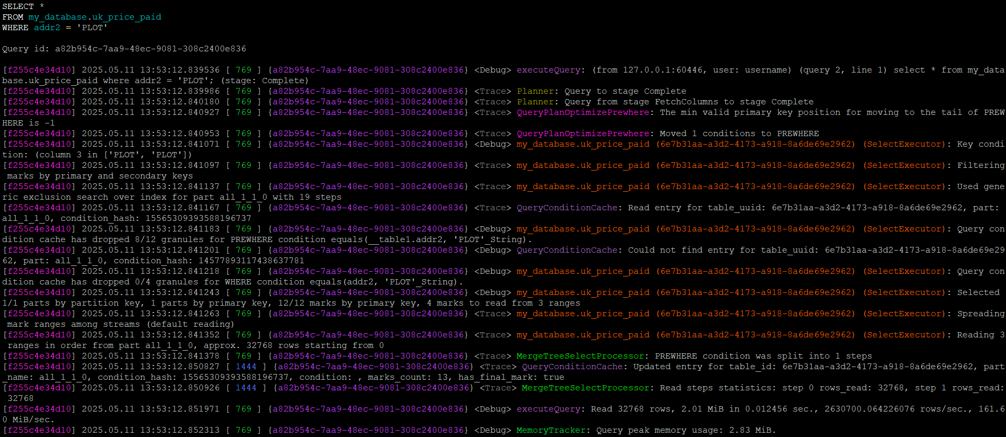

Записи лога с использованием индекса – видим, что используется pk в 3м столбце:

(SelectExecutor): Key condition: (column 3 in ['PLOT', 'PLOT'])
(SelectExecutor): Filtering marks by primary and secondary keys
(SelectExecutor): Used generic exclusion search over index for part all_1_1_0 with 19 steps
(SelectExecutor): Query condition cache has dropped 8/12 granules for PREWHERE condition equals(__table1.addr2, 'PLOT'_String).
(SelectExecutor): Query condition cache has dropped 0/4 granules for WHERE condition equals(addr2, 'PLOT'_String).
(SelectExecutor): Selected 1/1 parts by partition key, 1 parts by primary key, 12/12 marks by primary key, 4 marks to read from 3 ranges
(SelectExecutor): Spreading mark ranges among streams (default reading)
(SelectExecutor): Reading 3 ranges in order from part all_1_1_0, approx. 32768 rows starting from 0

Проверяем использование индексов через EXPLAIN.

Проверяем запрос без primary_key поля:

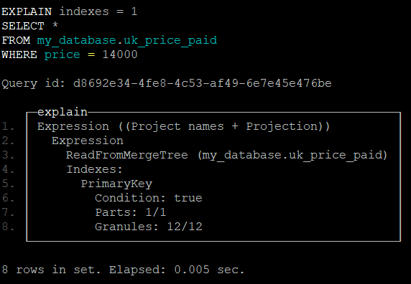

Полей keys в выводе нет.

Проверяем запрос с primary_key полем:

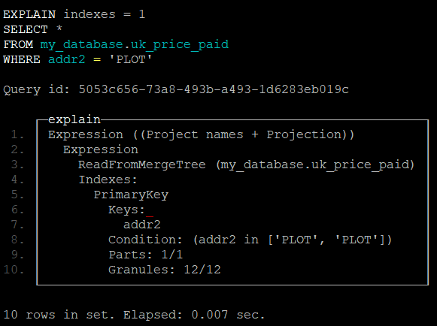

Вывод показал, что используется primary_key поле addr2.

